

ROSSENDALE BOROUGH COUNCIL FORWARD PLAN
FOR THE FOUR MONTH PERIOD 1st OCTOBER 2007 TO 31st JANUARY 2008

The Forward Plan sets out the details of the key decisions which the Cabinet or Officers expect to take during the next four month period and beyond where possible. The Plan is updated every month and is available to the public 14 days before the beginning of each month.

A Key Decision is defined as one that either:

a) is, in value worth more than £100,000, or
b) has a significant impact because (for example) it either:
(i) affects individuals or organisations outside the Borough;
or
(ii) will have a long term (more than 5 years) or permanent effect on the council or the borough.
The current members of the Cabinet are:

Councillor Duncan Ruddick Leader of the Council

Councillor William Challinor Deputy Leader and Portfolio Holder Regenerating and Promoting Rossendale

Councillor Judith Driver Portfolio Holder for a Clean and Green Rossendale

Councillor Brian Essex Portfolio Holder for a Well Managed Council

Councillor Janet Graham Portfolio Holder for Health and Wellbeing

Councillor Alison Tickner Portfolio Holder for Quality Services for Customers

The Council’s Management Team comprises:

Carolyn Wilkins Chief Executive
Helen Lockwood Deputy Chief Executive
George Graham Executive Director of Resources
Linda Fisher Head of Planning, Legal and Democratic Services
Phil Seddon Head of Financial Services
Liz Murphy Head of Human Resources
Carole Todd Head of Street Scene and Liveability
Ilona Snow-Miller Head of Community and Partnerships
Lesley Noble Head of Policy and Change Management
Jon Sharples Head of Economic Regeneration and Strategic Housing
Andrew Buckle Head of Customer Services and E-Government

Anyone wishing to make representations about any of the matters listed below may do so by contacting the relevant officer listed against each key decision.

Under the Access to Information Procedure rules set out in the Council’s Constitution, a key decision may not be taken, unless:

- It is published in the Forward Plan
- 5 clear days have lapsed since the publication of the Forward Plan; and
- if the decision is to be taken at a meeting of the Cabinet, 5 clear days notice of the meeting has been given

The law and the Council’s Constitution provide an exception that allows urgent key decisions to be made, even though they have not been included in the Forward Plan. This is provided for in Rule 15 (General Exception) and Rule 16 (Special Urgency) of the Access to Information Procedure Rules.

The Forward Plan also contains details of significant decisions which will be considered by the Cabinet with recommendations to Full Council.

Copies of the following documents may be inspected at the Rossendale Borough Council One Stop Shop, Town Centre Offices, Lord Street, Rawtenstall, Rossendale, Lancashire, BB4 7LZ or accessed from the Council’s website www.rossendale.gov.uk

- The Council’s Constitution
- The Forward Plan
- Reports on the key decisions to be taken
- The minutes or decision notice for each key decision, which will normally be published 4 working days after having been made.

Members of the public are welcome to attend meetings of the Cabinet and the dates and times of the meetings are published on the Council’s website www.rossendale.gov.uk or you may contact the Democratic Services Section on telephone number 01706 252423 or email Heather Moore, Committee and Member Services Manager at heathermoore@rossendalebc.gov.uk for further details.

Details of the decision to be taken | Decision to be taken by | Relevant Portfolio Holder | Expected Date of Decision | Proposed Consultees | Method(s) of Consultation | Documents to be considered by the decision taker | Representations may be made to the following officer
Disposal of Rawtenstall Mortuary | The Cabinet | A Well Managed Council | October 2007 | Portfolio Holder | Meetings | Report | Mike Forster, Property Services Manager Tel: 01706 252442 Email@ michaelforster@rossendalebc.gov.uk
Review of the Purchase Land Rental System | The Cabinet | A Well Managed Council | October 2007 | Portfolio holder | Meetings | Report | Mike Forster, Property Services Manager Tel: 01706 252442 Email@ michaelforster@rossendalebc.gov.uk
Locality Plan | The Cabinet | A Well Managed Council | October 2007 | Lancashire County Council | Meetings | Report | George Graham, Executive Director of Resources Tel: 01706 252428 Email@ georgegraham@rossendalebc.gov.uk
Employment Land Study | The Cabinet | Regenerating and Promoting Rossendale | October 2007 | Lancashire County Developments Ltd | Meetings | Report | Stephen Stray Senior Planning Officer  Tel: 01706252410 Email: stephenstray@rossendalebc.gov.uk
Review of Planning Code of Conduct | Full Council | Regenerating and Promoting Rossendale | October 2007 | Development Control Committee | Meetings | Report | Linda Fisher, Head of Planning, Legal and Democratic Services. Tel: 01706 252447 Email: lindafisher@rossendalebc.gov.uk
Former Whitworth Neighbourhood Office | The Cabinet | A Well Managed Council | October 2007 | Property offered for sale on open market by way of sealed tender bid | Local paper/Manchester Evening News/Council’s Web Site and signs erected on each of the buildings | Report | Michael Forster, Property Services Manager Tel: 01706 252442 Email: michaelforster@rossendalebc.gov.uk
Disposal of land: Henrietta Street, Bacup | The Cabinet | A Well Managed Council | October 2007 | Whitworth Town Council and Whitworth Ward Councillors | Meetings | Report | Mike Forster, Property Services Manager Tel: 01706 252442 Email: michaelforster@rossendalebc.gov.uk
Sustainable Community Strategy | Full Council | Health and Wellbeing | October 2007 | Portfolio Holder | Report | Report | Ilona Snow Miller, Head of Community and Partnerships Tel: 01706 252412 Email: ilonasnow-miller@rossendalebc.gov.uk
Polling Station Review | Full Council | A Well Managed Council | October 2007 | Public Consultation | Website, questionnaires | Report | Joanne Smith, Elections Manager Tel: 01706 252446 Email: joannesmith@rossendalebc.gov.uk
Biodiversity Policy Statement | Cabinet | A Well Managed Council  Clean and Green Rossendale | October 2007 | Managers and LSP Environment Theme Group | Meetings | Report | George Graham, Executive Director of Resources Tel: 01706 252428 Email@ georgegraham@rossendalebc.gov.uk
Policy for amended drawings submitted during the planning process (Validation Policy) | The Cabinet | Regenerating and Promoting Rossendale | November 2007 | Development Control Committee | Meetings | Report | Linda Fisher, Head of Planning, Legal and Democratic Services Tel: 01706 252447 Email: lindafisher@rossendalebc.gov.uk
Submission of Core Strategy | Full Council | Regenerating and Promoting Rossendale | November 2007 | Consultees identified in Forward Planning consultation database and in accordance with PPS12 and regulatory requirements. | Consultation in accordance with Regulations 27& 28 of the TCPA (Local Development) (England) Regulations 2004 for the submission of the document to the Secretary of State and examination by Planning Inspectorate. | Core Strategy, Final Sustainability Appraisal and Statement of Communication. | Stephen Stray Senior Planning Officer  Tel: 01706252410 Email: stephenstray@rossendalebc.gov.uk
Licence Conditions for Private Hire/Hackney Carriage Vehicles | The Cabinet | A Well Managed Council | November  2007 | Licensing Committee | Meetings | Report | Tracy Brzozowski, Licensing Manager Tel: 01706 238602 Email tracybrzozwski@rossendalebc.gov.uk
Approval of the Allocation Development Plan Document (DPD) for consultation | The Cabinet | Regenerating and Promoting Rossendale | November 2007 | The issues and options documents will be deposited for public consultation | Consultation in accordance with Regulation 25 of the TCPA (Local Development) (England) Regulations 2004. Consultation will also be in accordance with the 2nd Draft Statement of Community Involvement | Allocation DPD | Stephen Stray Senior Planning Officer  Tel: 01706252410 Email: stephenstray@rossendalebc.gov.uk
Approval of the Proposals Map for consultation | The Cabinet | Regenerating and Promoting Rossendale | November 2007 | The issues and Options documents will be deposited for public consultation | Consultation in accordance with Regulation 25 of the TCPA (Local Development) (England) Regulations 2004. Consultation will also be in accordance with the 2nd Draft Statement of Community Involvement | Proposals Map | Stephen Stray, Senior Planning Officer  Tel: 01706 252410 Email: stephenstray@rossendalebc.gov.uk
Rossendale Black & Minority Ethnic Housing Strategy | Cabinet | Regenerating and Promoting Rossendale | November 2007 | BME Groups, stakeholders, providers, external partners | Draft Report and focus sessions | Report | Steve Jackson, Housing Market Restructuring Manager, Tel: 01706 252401, e-mail: stephenjackson@rossendalebc.gov.uk no later than 1st October 2007.
Rossendale Supported Housing Strategy | Cabinet | Regenerating and Promoting Rossendale | November 2007 | Stakeholders, providers, partners, public | Draft Report and meetings, advertising through website and press. | Report | Steve Jackson, Housing Market Restructuring Manager, Tel: 01706 252401, e-mail: stephenjackson@rossendalebc.gov.uk no later than 1st October 2007.
Approval of an Environment Policy | Cabinet | A Clean and Green | December 2007 | Members and staff | Staff meetings and consultation | Report | Philip Mepham, Interim Manager, Environmental Health  Tel: 01706 252566  Email: philipmepham@rossendalebc.gov.uk
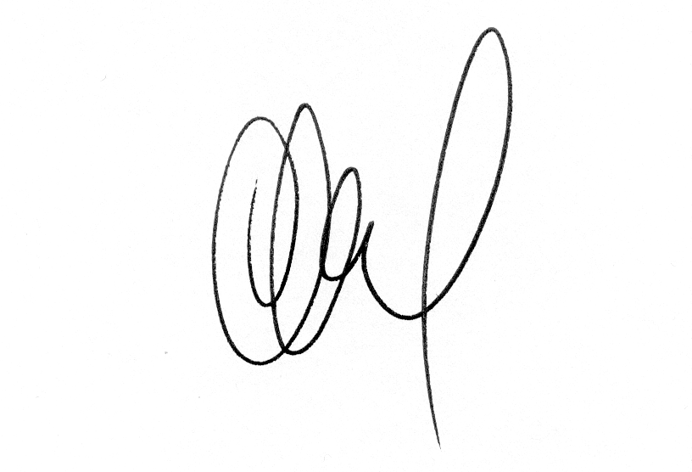
Duncan Ruddick
Leader of the Council

