Response to questions raised by

Rossendale Borough Council in relation to a proposed Agricultural Farm Building

Land at Kilnfield Farm
Helmshore
Rossendale
BB4 4AR

E Taylor & Sons

Planning Application Number 2014/0551

In response to an e-mail received from Richard Elliott of Rossendale Borough Council and discussions on Site with Mr Elliott on Monday 09 March 2015 in relation to the chosen location for the proposed building, we have before arriving at the selected site, considered various potential sites across the farm, however there are a number of specific considerations and requirements for the positioning of a Livestock Building, these are listed below:
- Accessibility
- 2 prevailing winds
- Availability of water
- Droving of livestock
In addition to these specifics for farm buildings we have also considered the following reasons in arriving at the chosen site:
- Cost of construction
- The requirements to level / excavate on the site
- Screening
- Loss of land and the requirements for new roadways
- Distances from water courses i.e. Musbury Brook and Holden wood Reservoir
- Visibility from Helmshore
- Visibility from neighbouring properties
The following alternative sites were considered and disregarded on the grounds listed below each site:
- Site adjacent to Kilnfield Farm House
This site was dismissed on the following Grounds
- Droving – live stock do not like to go up hill and will naturally head downhill
- Prevailing winds, the orientation needed for the building would result in land take of some of the farms most productive land
- The need to excavate and or fill on the site would result in the need for expensive retaining walls
- Screening – the site is very open and has open aspect from much of Helmshore Village
- Openly visible from 5 neighbouring properties
- Water – there is only 1 spring supply above this site and to install mains water to this height above sea level would require installation of a water pump.

- Site opposite Entrance to Hill End Farm
This site was dismissed on the following Grounds
- Droving – live stock do not like to go up hill and will naturally head downhill
- Prevailing winds, the orientation needed for the building would result in land take of some of the farms most productive land
- Screening – the site is very open and has open aspect from much of Helmshore Village
- Openly visible from 4 neighbouring properties
- Water – there is only 1 spring supply above this site and to install mains water to this height above sea level would require installation of a water pump.
- The site is narrow and at a bottle neck on the farm, access in the winter is often difficult.

- Rake Foot Farm
This site was dismissed on the following Grounds
- Access difficulties with weight restrictions on access via Reservoir Embankment and also the narrow nature of the access roadway from Helmshore side
- Proximity to Reservoir
- Poor soil and clay subsoil
- Open Aspects and visibility from Grane Road and Haslingden

- Site Opposite West End Villas
This site was dismissed on the following Grounds
- The need to excavate and or fill on the site would result in the need for expensive retaining walls
- The length of new roads required to access the site would result in excessive land take
- Screening – the site relatively open and also close to Park Road and West End Villas, also closer to Musbury Brook
- The nature of the sub soil (Boulder Clay) would increase construction costs.
The merits of the chosen site foar outweigh any negatives and has been chosen in our opinion as the most suitable site on the farm on the following grounds:
- Accessibility
The Access Road from West End Villas to the proposed entrance is within our ownership as is the rest of the roadways running through the farm, all other users simply have a right of way and obligation to maintain the road. The point of entry will require minimal re-profiling of the roadside verge, and will provide the necessary visibility splays to allow joining th road safely.

The chosen site will result in minimal land loss through the construction of a new short access road.

- Prevailing Winds
The orientation of the building has been set to ensure that the prevailing wind and weather hits the rear and side elevations, allowing sufficient uplift of air and air flow through the building. Even with open fronted buildings, if positioned wrongly, there is still potential for stale and ‘damp’ air to remain within the building, and when livestock are present, this can increase the rates of infection with diseases such as Pneumonia, a killer in young cattle especially.

Further the chosen orientation will prevent rain from driving in to the building.
- Availability of Water
The plan attached with this document indicates the location of spring water supplies and also the approximately location of the one inch main supply which runs through the farm. The chosen location has potentially 4 spring water supplies which could be connected ensuring sufficient supplies for livestock, along with the mains water supply which is available for use should there ever be a requirement for additional water.

- Droving of Livestock
The site sits conveniently towards the lower parts of the farm, livestock will happily move down hill with little stress or effort, however moving livestock uphill is more difficult, the chosen site allows stock to be readily and easily moved using existing field patters and fencing.

- Cost of construction
The position as selected has good subsoil and is solid for foundations and will reduce the cost for these elements of the structure, and as a result the whole development along with its proximity to existing roads.

- The requirements to level / excavate on the site
The chosen site is one of the more level areas of the farm, and is easilt accessible from teh chosen access point, this will therefore not require significant excavation or fill for the site or demand any retaining walls.

- Screening
The chosen site is one of the better screened areas of the farm, with shelter / screening provided by the existing hedgerows and willow plantation along with mature roadside trees.

If additional screening is required, we would be willing to agree with the Council the planting of native hedgerows / mixed deciduous trees along the roadside within reason and along the site boundary.

As pointed out to Richard, we are already working closely with the Environment Agency on their scheme in Musbury Brook to facilitate tree planting to offset their carbon footprint in relation to the new Trash Screen, and have regularly undertaken schemes of tree planting around the farm and have plans to establish new hedgerows along field boundaries, however if planting is required, this must be a reasonable amount, of say 50 native mixed deciduous broadleaf trees.

- Distances from water courses i.e. Musbury Brook and Holden wood Reservoir
The site is considered to be a safe distance from Musbury Brook and with water flow away from the Brook will prevent any potential for contamination.

- Visibility from Helmshore
The chosen site has limited visibility from the Village of Helsnore and due to existing tree planting hedges etc does not disrupt any open aspects or cause a ‘blot’ on the landscape visible from great distances as would be the case with other sites further up the farm.

- Visibility from neighbouring properties
Due to the chosen sites position in the lower parts of the farm, existing established woodlands, hedges and trees provide good levels of screening from nearby neighbouring properties. IT should be noted that we did consult with the residents of the properties from where there may be some element of visibility of the site prior to submission of the application, further none of the residents who have visibility of the site from the ir own property have raised any objection to the application.

To re-iterate our discussions of earlier this week, this building is essential to allow us to continue our farming enterprise and to move with modern times, it is essential for Livestock Welfare, providing housing for both cattle and for lambing sheep and will provide a solid base for all farming operations carried out on the farm.
I hope that the attached aids you in reaching your final recommendations in relation to the chosen site, as requested appended hereto are the following:
- Plan indication the alternative sites considered
- Plan indicating the location of the gas main and fibreoptic telecommunications line
- Plan illustrating the location of spring water supplies
- Field drainage plan – this is to the best of our knowledge the location of existing drains in the field, although the presence of the utilities and disruption over the years hare resulted in a number of these drains failing, as such we will be upgrading and replacing the drainage in the area to facilitate the building with cut off drains etc.

- Plan indication the alternative sites considered
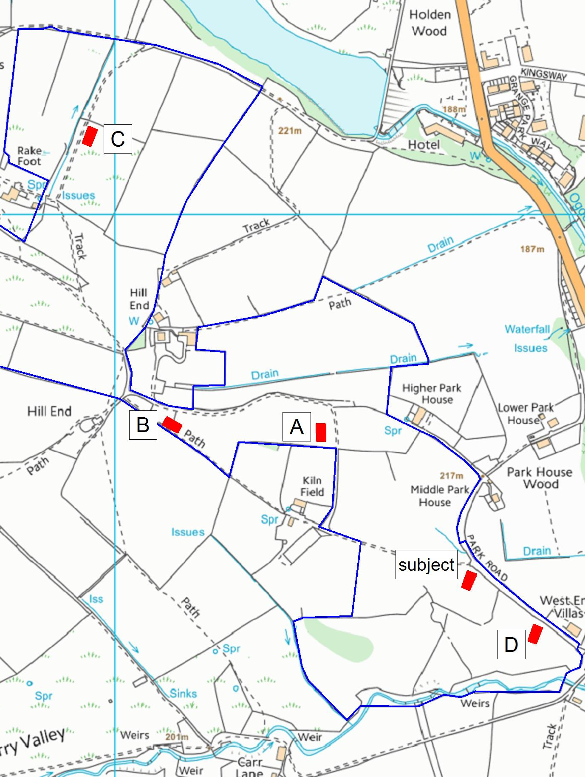
Plan indicating alternative sites

A Site adjacent to Kilnfield
B Site opposite entrance to Hill End
C Site at Rake Foot Farm
D Site opposite West End Villas.

- Plan indicating the location of the gas main and fibreoptic telecommunications line
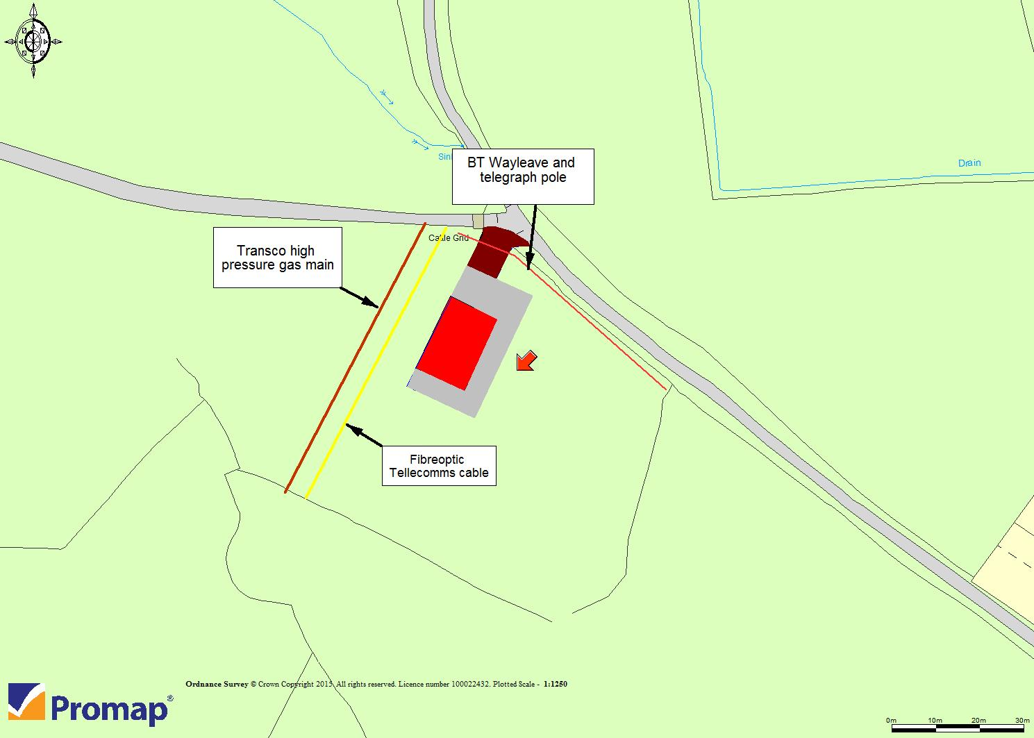
- Plan illustrating the location of spring water supplies and Water Main
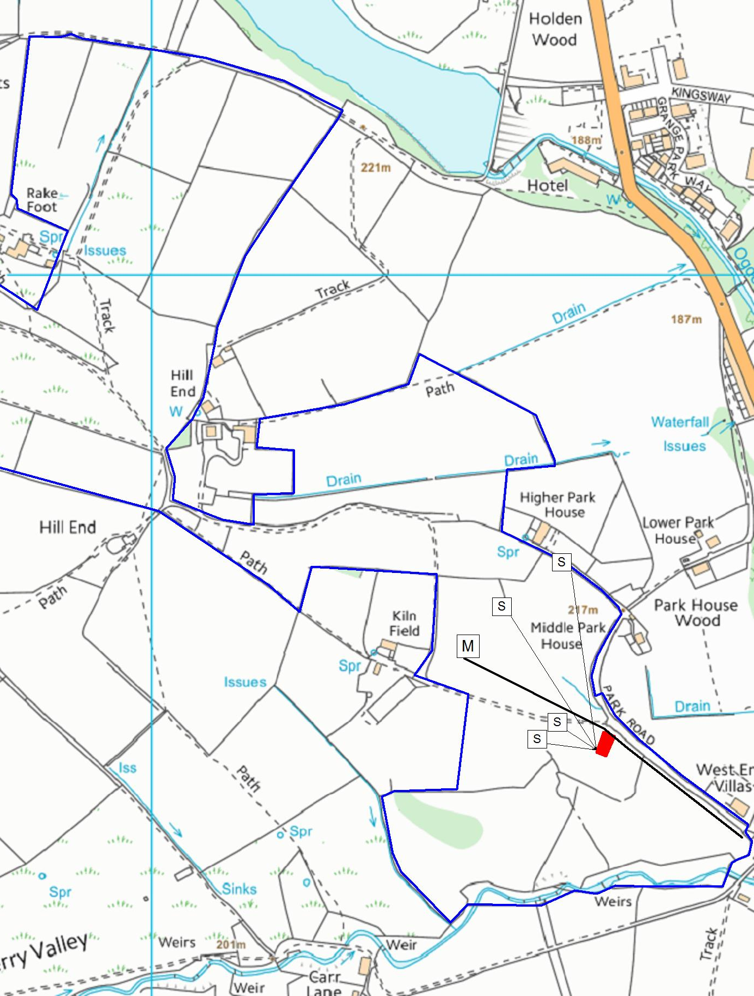
S indicates approximate rising point of spring water supplies and their potential flow to the buildings.
M indicates approximate location of 1 inch mains water pipe
- Field Drainage Plan
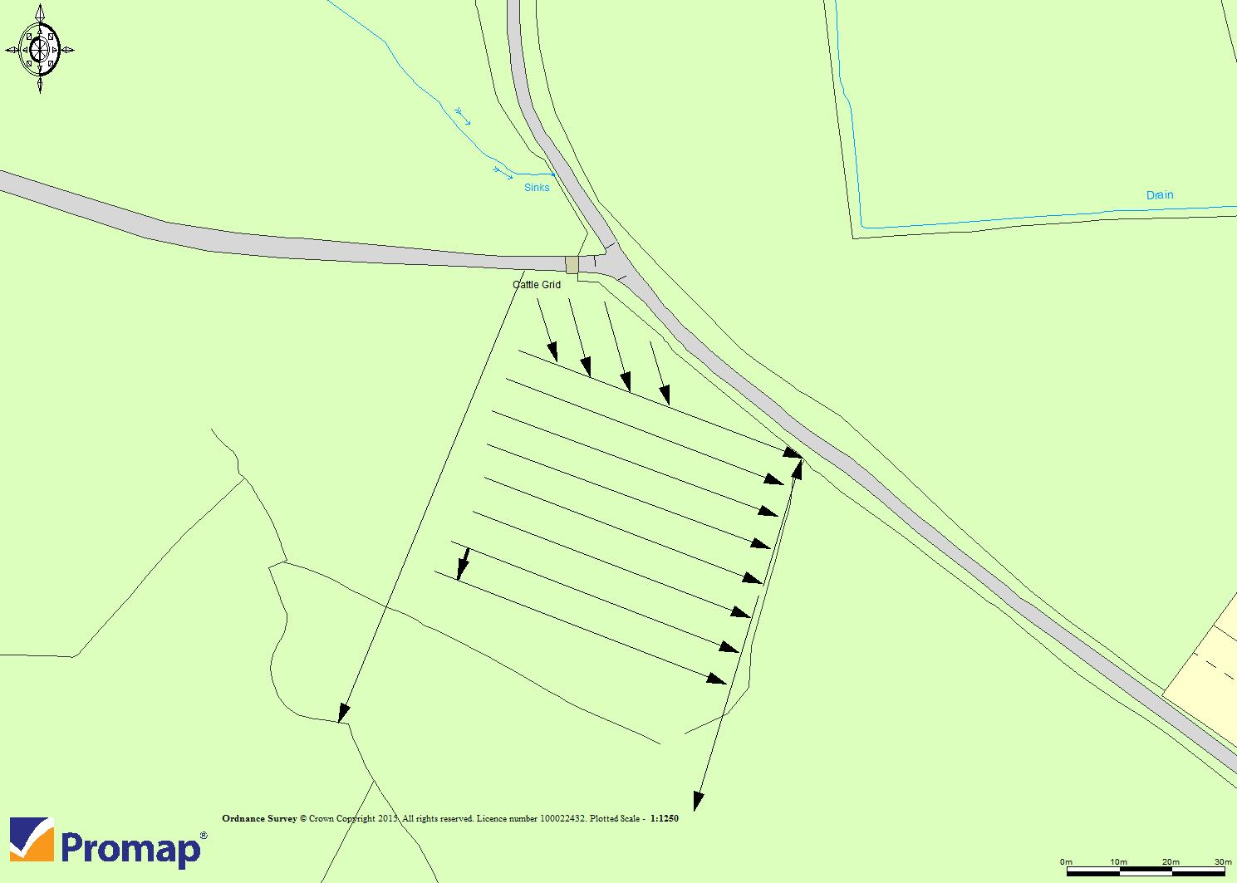
Field drainage at regular 20’ intervals and parallel drainage pattern running to field ditch to the eastern field boundary, with cut off drain at top side of the gas main

