Rossendale Borough Council

INVITATION TO TENDER FOR WORKS AT EGDESIDE PARK WHEELED SPORTS AREA
INSTRUCTIONS AND DETAILS OF CONTRACT

Rossendale Borough Council

INVITATION TO TENDER DEVELOPMENT OF THE WHEELED SPORTS AREA AT EDGESIDE PARK

SUMMARY INSTRUCTIONS AND DETAILS OF CONTRACT
ITEM | CONTRACT DETAILS
Contract Description: | Rossendale Borough Council (RBC) is seeking tenders from competent suppliers to tender for improvement works to the wheeled sports area at Edgeside Park  The Contractor shall be deemed to have satisfied itself before submitting its tender as to the accuracy and sufficiency of the rates and prices stated in the tender which shall (except in so far as is otherwise provided in the Contract) cover all the Contractor’s obligations under the Contract and the Contractor shall be deemed to have obtained for itself all necessary information as to risks and any other circumstances which might reasonably influence or affect the Contractor’s tender.
Insurance Requirements: | All adequate insurance to run the along side the contract as required.  Please submit certificate of public liability insurance.
Completion of Contract: | 29th November 2024
Procuring Officer: | Any queries must be addressed to;  David McChesney  Rossendale Borough Council  Henrietta Street  Bacup, ,  Tel:- 07551 151582  email: davidmacchesney@rossendalebc.gov.uk  before: Friday 7th June 2024 at 17:00
Intention to Tender Form | Please return the Intention to Tender form as soon as possible and no later than Friday 31st May 2024
Submission instructions: | Send all required documents to; tenders@rossendalebc.gov.uk  The documents must be as attachments in pdf form or equivalent and not links to file hosting sites.  Alternatively, provide hard copy of the tender document in envelope marked “Tender-Strictly Confidential – David McChesney to be opened by addressee only”. The envelope must bear no name or other distinguishing matter or mark revealing the identity of the sender. Tenders to be sent to address below.
Tenders to be sent to: | Committee and Democratic Services Manager  Rossendale Borough Council  Room 213  The Business Centre  Futures Park  Bacup  OL13 0BB  Or tenders@rossendalebc.gov.uk
Date/time for Tender return: | 12:00 noon on 21st June 2024

Timetable
This timetable is indicative only. The Council reserves the right to change it at its discretion.

Stage | Date(s)/time
Submission of Tenders | 12:00 noon 21st June 2024
Evaluation of Tenders | 24th / 25th June 2024
Notification of result of evaluation | 26th June 2024
Engagement with the community to revise and refine the design | From Monday 8th July 2024
Final design and bill of quantities completed | 9th August 2024
Completion Date | 29th November 2024

CHECKLIST FOR TENDERERS
Failure to provide all of the items in the checklist may cause your Tender to be non-compliant and not considered.

No | Item | Included in Tender?
 | Completed Bill of Quantities with final price.
 | A layout plan (and/or 3D visual) of the design and proposals for the site
 | An A4 document detailing the approach to community engagement for revising and refining the design
 | An A4 document identifying the social value included in delivering this project
 | 2 references from previous similar schemes delivered within the past 4 years
 | Details of 2 similar schemes delivered within the past 4 years – plans and photos of the completed facilities.
 | Certificate of non-canvassing and non-collusion.
CONTENTS

1 Background 7
2 Tender submission requirements 2
3 Contract documents 9
4 Tender evaluation and award criteria 10
5 Information required …………………………………………………… 10
6 Freedom of information act and environmental information regulations statement 14

SCHEDULES

1 Specification
2 Part 1 - contract particulars
Part 2 - standard terms and conditions
Part 3 - special terms and conditions
3 Form of tender
4 Certificate of non-collusion and non-canvassing
5 Intention to tender form
IMPORTANT NOTICE

This Invitation to Tender (“ITT”) is issued to those shortlisted to tender (“Tenderers”) to Rossendale Borough Council (the “Council”) for the development of the wheeled sports area at Edgeside Park, (the “Contract”), their professional advisers and other parties essential to preparing a tender for this Contract (the “Tender”) and for no other purpose.
The contents of this ITT and of any other documentation sent to you in respect of this tender process are provided on the basis that they remain the property of the Council and must be treated as confidential. If you are unable or unwilling to comply with this requirement you are required to destroy this ITT and all associated documents immediately and not to retain any electronic or paper copies.

No Tenderer will undertake any publicity activities with any part of the media in relation to the Contract or this ITT process without the prior written agreement of the Council, including agreement on the format and content of any publicity.
This ITT is made available in good faith. No warranty is given as to the accuracy or completeness of the information contained in it and any liability or any inaccuracy or incompleteness is therefore expressly disclaimed by the Council and its advisers.
The Council reserves the right to cancel the tender process at any point. The Council is not liable for any costs resulting from any cancellation of this tender process nor for any other costs incurred by those tendering for this Contract.
You are deemed to understand fully the processes that the Council is required to follow under relevant European and UK legislation, particularly in relation to the Public Contracts Regulations.
- BACKGROUND

  - Rossendale Borough Council have secured funding to redevelop the wheeled sports area at Edgeside Park, Waterfoot as part of the current masterplan of proposed improvements. The aim of this tender is to secure a preferred contractor/designer. The designer / contractor will work with the Council and a community of wheeled sports enthusiasts to revise and refine the design based on local needs and wants. The Council will then continue to work with the contractor to construct the new facility on site.

  - The site for the proposed works is located centrally in Edgeside Park and covers an area of approximately 474m². The site is highlighted within the red line on the two maps below.

Coordinates for the site are; 53.697472, -2.244583

The site is currently a wheeled sports area and shares a fenced off area with a MUGA which is immediately to the North of it. The main footpath in the park runs North and South along the Eastern border of the fenced area.

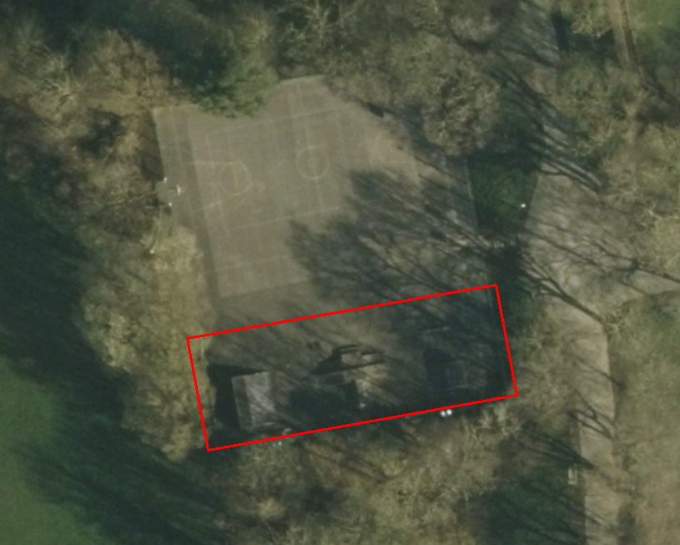

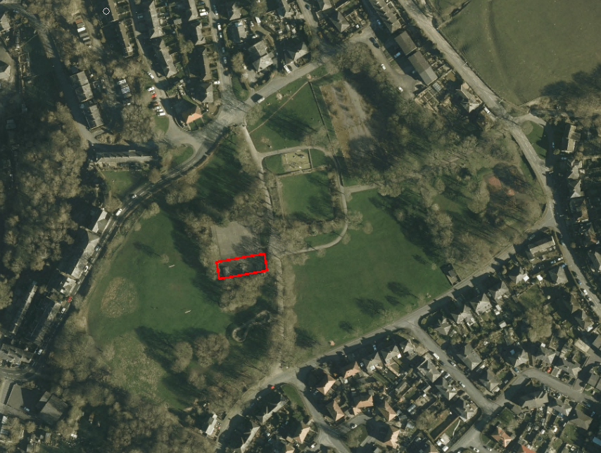

  - The existing wheeled sports facility consists of a bitmac surface with a range of steel features including ramps, platforms and rails. The entrance to the fenced area is open (ungated). The site sits within a fenced Multi activity area at the foot of a small grass banking. The site, as with other areas of the park, can suffer from drainage and water run off issues during the wetter months.

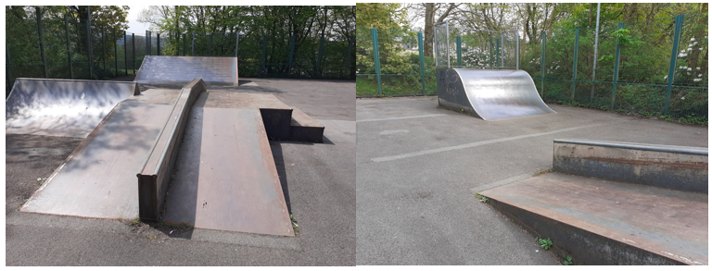

  - It is proposed to reuse (where appropriate) refurbish and/or replace the existing facilities, which will cater for all wheeled sports including skate boarding, inline skating/rollerblading, BMXing and scooting.

The design should:

- Cater for a wide range of abilities and ages (suggested age range is 5 – adult). Consultation has highlighted the importance of having mellow features for beginners and also keeping some of the larger features if possible.
- Cater for all wheeled sports (as described as above). The consultation showed how important all the disciplines are in this location not just skateboarding
- Be constructed of durable materials
- Be mindful of the potential for anti-social behaviour including arson.
- Maximise the available space and be mindful of the adjacent existing uses (traditional play and MUGA).
- The final completed project will be subject to a thorough ROSPA playground inspection. Any high risk issues raised, over and above those expected in such a facility should be dealt with and rectified.

A summary of the consultation result is shown in the appendix.

  - The materials will be durable and suitable for the proposals, including:

- Smooth concrete surfacing
- Steel equipment (such as grind rails etc.)
- There should be seamless joins between any new surfacing and existing bitmac surfacing to minimise the risks for accidents and to ensure a smooth transition for users.
- The skateboard equipment should be sensibly spaced out to maximise usage; not spread out to fill a space. The focus should be on user enjoyment and improving skills.
- Drainage and surface water run-off should be considered as part of the proposals, if required.
- Feedback from young people should be taken into consideration in the design as far as practicable and within the confines of the budget.
- The design should not incorporate features below ground level for drainage and safety reasons.
- As per the consultation the design should also include an element of seating to prevent people from sitting on the ramps and features.

  - Rossendale Borough Council have secured £123,580.62 which is exclusive of VAT.

  - The bill of quantities must include all site set up and preliminary costs, design time, all materials required, labour for construction and any other associated costs. It must also include any costs of making good areas of ground disturbed by the works. It must also include the costs of liaising and workshops with the young people who will be using the site upon completion.
  - Council Officers will choose a preferred contractor based on the criteria set out below in the evaluation and award section. The winning design will be shared with the local wheeled sports community and consultations will be held where the group can revise and refine the design based on their collective preferences. 17 people who responded to the consultation have expressed an interest in being involved in this process.

  - If you have any questions or require any clarifications, please contact David McChesney, Waste Transfer Station, Henrietta Street, Bacup, OL13 0AR, Tel:- 07751 151 582 email: davidmcchesney@rossendalebc.gov.uk

  - Other than the person or persons identified above, no Council employee or member of the Council has the authority to give any information or make any representation (express or implied) in relation to this ITT or any other matter relating to the Contract.

  - Please note that the Council’s responses to any queries or clarification requests may, at the Council’s discretion, be circulated to all Tenderers.

  - The Council reserves the right to issue supplementary documentation at any time during the tendering process to clarify any issue or amend any aspect of the ITT. All such further documentation that may be issued shall be deemed to form part of the ITT and shall supplement and/or supersede any part of the ITT to the extent indicated.

  - Tenderers must obtain for themselves at their own expense all information necessary for the preparation of their Tenders.

A site visit is recommended to get a feel for the surroundings to better inform the design process and quotation. It will provide an understanding of the condition of the current features and inform whether these can be incorporated into a new design. The sites are fully open to the public at all times.

  - Under the Contract the Council will require compliance with its policies. Tenderers are advised to satisfy themselves that they understand all of the requirements of the Contract before submitting their Tender.

  - The Tender must be received in accordance with the relevant instructions no later than the time and date indicated.

- TENDER SUBMISSION REQUIREMENTS

  - Tenders must be written in the English language.

  - Tenders must provide responses referring back to the numbering format as set out in section 5 of this ITT.

  - Only one Tender is permitted from each Tenderer. In the event that more than one is submitted by a Tenderer, the one with the latest time of submission will be evaluated and the other(s) disregarded.

  - The Tender (including price) should remain valid for a minimum period of 90 days.

  - The Tender must not be qualified in any way.

  - Any signatures must be made by a person who is authorised to commit the Tenderer to the Contract.

  - Your full registered business/name and main office address must also be provided on all documents.
- CONTRACT DOCUMENTS

  - Any resulting Contract will consist of the Contract Particulars (to be completed), the Standard Terms and Conditions, the Special Terms and Conditions (all as set out in Schedule 2) and the successful Tender. The Contract will be subject to English law and the exclusive jurisdiction of the English Courts.

  - This Council is bound by procurement rules and cannot enter into any negotiations on the Tender or Contract.

  - Any contract award will be conditional on the Contract being approved in accordance with the Council’s internal procedures and the Council being generally able to proceed and may allow for a standstill period to elapse before sending confirmation of contract award to the successful Tenderer.

- TENDER EVALUATION AND AWARD CRITERIA

  - The Council does not undertake to accept the lowest or any Tender and reserves the right to accept the whole or any part of any Tender submitted.

  - Each Tender will be checked initially for compliance with all requirements of the ITT.

  - Tenders will be evaluated against the award criteria set out below.

  - During the evaluation period, the Council reserves the right to seek clarification in writing or by means of a clarification meeting from any or all of the Tenderers, to assist it in its consideration of their Tenders.

  - The Council may decide to interview Tenderers or hold clarification meetings to assist its tendering process, and Tenderers will be notified in due course.

  - Tenders will be evaluated taking into consideration the following award criteria:

The tender assessment will be based on the following criteria; weightings are shown below:

Questions | Score available
Design – 60%
Design of the including consideration of the age/ability range and for all the wheeled sports | 20%
Variation of and relationship between features | 20%
Size of proposals (i.e. footprint of the proposals in relation to the space available) | 20%
Construction and Safety – 15%
Construction detail | 5%
Safety of design and approach to health and safety | 5%
Warranty | 5%
Other – 15%
Quality of Tender Submission | 5%
Approach to engagement with young people | 10%
Social Value - 10%
Rossendale Borough Council is committed to delivering social value through commissioning and procurement activity, and includes the wider social, environmental and/or economic benefit from procuring services | 10%
TOTAL | 100%

- INFORMATION REQUIRED

  - Tender information

Tenderers are asked to indicate:
    - Their proposed methodology for fulfilling the Contract and meeting the Specification;
    - A contract timetable which the Tenderer proposes to adhere to;
    - A project management structure and principal point of contact for the Council who will be Contract Manager;
    - The proposed personnel identified for the provision of the Contract and whether they will be exclusively deployed to the Council and any other resources which will be used.

  - Pricing

    - Tenderers must complete the Pricing Schedule set out in Schedule 3 to provide all of the obligations under the Contract.
    - All Prices shall be stated in pounds sterling and exclusive of VAT.

- Freedom of Information Act and Environmental Information Statement

6.1 The Council is subject to The Freedom of Information Act 2000 (“Act”) and The Environmental Information Regulations 2004 (“EIR”).

6.2 As part of the Council’s obligations under the Act or EIR, it may be required to disclose information concerning the procurement process or the Contract to anyone who makes a reasonable request.

6.3 If Tenderers consider that any of the information provided in their Tender is commercially sensitive (meaning it could reasonably cause prejudice to the organisation if disclosed to a third party) then it should be clearly marked as "Not for disclosure to third parties” together with valid reasons in support of the information being exempt from disclosure under the Act and the EIR.

6.4 The Council will endeavour to consult with Tenderers and have regard to comments and any objections before it releases any information to a third party under the Act or the EIR. However, the Council shall be entitled to determine in its absolute discretion whether any information is exempt from the Act and/or the EIR, or is to be disclosed in response to a request of information. The Council must make its decision on disclosure in accordance with the provisions of the Act or the EIR and can only withhold information if it is covered by an exemption from disclosure under the Act or the EIR.

6.5 The Council will not be held liable for any loss or prejudice caused by the disclosure of information that:

6.5.1 Has not been clearly marked as "Not for disclosure to third parties" with supporting reasons (referring to the relevant category of exemption under the Act or EIR where possible); or

6.5.2 Does not fall into a category of information that is exempt from disclosure under the Act or EIR (for example, a trade secret or would be likely to prejudice the commercial interests of any person); or
6.5.3 In cases where there is no absolute statutory duty to withhold information, then notwithstanding the previous clauses, in circumstances where it is in the public interest to disclose any such information.

- Appendices
  - Consultation Summary
